Week 9: Why It Matters what you Believe – Drinking

- Myths about alcohol use in the Bible
- Three views on drinking
- Why it matters what you believe about drinking

- Myths about alcohol use in the Bible
The Bible explicitly states drinking is sinful
It sure would be nice if God gave us the 11 Commandments, with #11 being “Thou shalt not drink alcohol.”

Unfortunately, that commandment does not exist. As such, we are left with a question that Bible scholars have debated for quite awhile, and especially over the last 200 years.

Some people like to quote Proverbs 23:31 “Do not look on the wine when it is red, When it sparkles in the cup, When it swirls around smoothly;”

However, this would seem to indicate it is sinful to even look at wine? I think if you read these verse in the context of Proverbs 23:29-34, you see the prohibition is against those that …” who linger long at the wine”.

We know Jesus never drank alcohol
Let me emphasize the word “know” in this statement. We do not “know” whether Jesus drank alcohol. Scholars on both sides of the debate can make inferences and guesses.

Luke 7:33-34 “For John the Baptist came neither eating bread nor drinking wine, and you say, ‘He has a demon.’ The Son of Man has come eating and drinking, and you say, ‘Look, a glutton and a winebibber, a friend of tax collectors and sinners!’

DISCUSSION: What do you think it means when it says “The Son of Man has come eating and drinking?”

In a red-letter edition Bible, these words are red because Jesus is speaking. In Jesus’ own words, he says he “…has come eating and drinking”, and it goes on to say how Jesus is accused of being a winebibber. Proponents that believe Jesus did drink alcohol point to this verse as proof. Opponents state this is a “general saying” that speaks to the type of people Jesus chose to associate with on Earth.

Alcohol percentage matters
Another common thing I noticed in preparing for this class, is the numerous claims that Biblical alcohol wasn’t anywhere as potent as today’s alcohol. Some people claim this is because ancient brewers didn’t have access to the refined ingredients and technology today. Other claim it was because wine was diluted with water.

I don’t really care if the typical glass of wine was 1% or 15% alcohol by volume. I do know from reading the Old and New Testament that drunkenness was possible. The alcohol percentage doesn’t matter in the sense that people got drunk back then as well as today. The only thing that might be different is how quickly it took to get drunk.

“Good drinking” references are grape juice, “Bad drinking” references are alcohol
There are multiple Hebrew words referring to both fermented and unfermented grape juice.
- “yayin” occurs somewhere 120 times in the OT. From what I’ve found, scholars believe this refers to fermented wine; although there are some detractors that disagree that it could also refer to unfermented wine.
- “tirosh” occurs 37 times in the OT. This means fresh newly – expelled juice of the grape, or 'must' as it is sometimes called, and in some cases 'new wine' or 'sweet wine.'
- “aciyc” (aw-sees) occurs 4 times in the OT, and 'to squeeze out juice' therefore, it refers to just trodden out grape juice; new, sweet wine.

When the OT was translated to Greek, they used the word oinos to represent all three forms.

DISCUSSION: What problem does the single Greek word oinos present when trying to understand the Bible’s stance on drinking?

In the OT, Greek translators used oinos for both yayin and tirosh, which means it is difficult to understand if the reference was to fermented or unfermented grape juice. In some cases, you can deduce which one it is if you look at the context.

Some scholars state, that all references to “good drinking” refers to grape juice while all references to “bad drinking” is alcohol, but this doesn’t hold up when you look at the Old Testament usage of the words yayin, tirosh, and acicyc.

It does leave us in a bit of a quandary when we have to decide if oinos in the New Testament is referring to unfermented or fermented grape juice.

It would appear that God allowed the drinking of wine or “similar drink” translated “strong drink” in original KJV. The underlying Hebrew word is shekar and this always means intoxicating drink.

Deut 14:26 “And you shall spend that money for whatever your heart desires: for oxen or sheep, for wine or similar drink, for whatever your heart desires; you shall eat there before the LORD your God, and you shall rejoice, you and your household.”

- Three Views on Drinking
DISCUSSION: Which, if any, of these views do you think you can support Biblically?
When we look at these three views on drinking, I think you can find Biblical support that Drunkenness is always wrong, Abstinence is always right, and Moderation is allowed.

Drunkenness
The Bible clearly denounces drunkenness in both the Old and New Testament. It is clear that nothing good can come from drunkenness. I wholeheartedly believe that men and women cannot be drunkards and expect to go to Heaven.

I Cor 6:9-10 “Do you not know that the unrighteous will not inherit the kingdom of God? Do not be deceived. Neither fornicators, nor idolaters, nor adulterers, nor homosexuals, nor sodomites, nor thieves, nor covetous, nor drunkards, nor revilers, nor extortioners will inherit the kingdom of God.:”

Gal 5:19-21 “Now the works of the flesh are evident, which are: adultery, fornication, uncleanness, lewdness, idolatry, sorcery, hatred, contentions, jealousies, outbursts of wrath, selfish ambitions, dissensions, heresies, envy, murders, drunkenness, revelries, and the like; of which I tell you beforehand, just as I also told you in time past, that those who practice such things will not inherit the kingdom of God.”

Eph 5:18 “And do not be drunk with wine, in which is dissipation; but be filled with the Spirit,”

DISCUSSION: Is the problem in this verse “wine” or is it “being drunk”?
Some commentaries I read state the bigger problem is wine itself, which leads to drunkenness. They make the claim that you cannot be filled with the Spirit and also drink.

Abstinence
The other end of the spectrum would be not drinking at all. I believe people select this option for one of two reasons: 1) They feel like the Bible prohibits drinking. I personally disagree, but I will not judge someone who believes it is wrong to drink. 2) They believe drinking is not the best choice for them individually.

I Peter 5:8 “Be sober, be vigilant; because your adversary the devil walks about like a roaring lion, seeking whom he may devour.”

I Cor 3:16-17 “Do you not know that you are the temple of God and that the Spirit of God dwells in you? If anyone defiles the temple of God, God will destroy him. For the temple of God is holy, which temple you are.”

I Thes 5:22 “Abstain from every form of evil.”
This verse is often a “fall-back” verse whereby Christians will say that should not do something because of what it might look like to somebody else. For example, I am a deacon here at Westside, and let’s say you see me coming out of a local bar. The fear is you might make the mental association that Kyle thinks it is OK to go in there, so it must be OK for me also. Personally, if you are over 21, I don’t care if you go in the bar. It is your choice. I do care if you stagger out drunk though.

Moderation
DISCUSSION: What does drinking in moderation mean?
There is no one definition of moderate drinking, but generally the term is used to describe a lower-risk pattern of drinking. According to the Dietary Guidelines for Americans, “drinking in moderation is defined as having no more than 1 drink per day for women and no more than 2 drinks per day for men. This definition is referring to the amount consumed on any single day and is not intended as an average over several days.”

I Tim 3:8 “Likewise deacons must be reverent, not double-tongued, not given to much wine, not greedy for money,”

I Tim 5:23 “No longer drink only water, but use a little wine for your stomach’s sake and your frequent infirmities.”

Titus 2:1-3 “But as for you, speak the things which are proper for sound doctrine: that the older men be sober, reverent, temperate, sound in faith, in love, in patience; the older women likewise, that they be reverent in behavior, not slanderers, not given to much wine, teachers of good things”

- Why it Matters What You Believe About Drinking
Your view on drinking is not the “Gospel” for others – Each of you here today needs to select one of three views on drinking. Regardless of which choice you make, it is imperative that you do not make your choice the “Gospel” (i.e., the “truth”) for someone else’s lives.

Constant temptation - Your decision to drink or not to drink is something that Satan will test you with on a routine basis. I won’t say that it will necessarily be a daily thing, but as a young person it is likely happen at least once a month if not once a week as go out with friends, go out with people from work, go to parties, etc.

Moderation is a short step away from drunkenness – If you choose the moderation route, you need to realize you are a potentially short step away from drunkenness, which is clearly sinful. As a moderate or social drinker, you will also need to figure out how much you can drink before you are “drunk”. The bible doesn’t provide us a Blood Alcohol Level at which drunkenness occurs, but you could always use the one for drinking and driving.

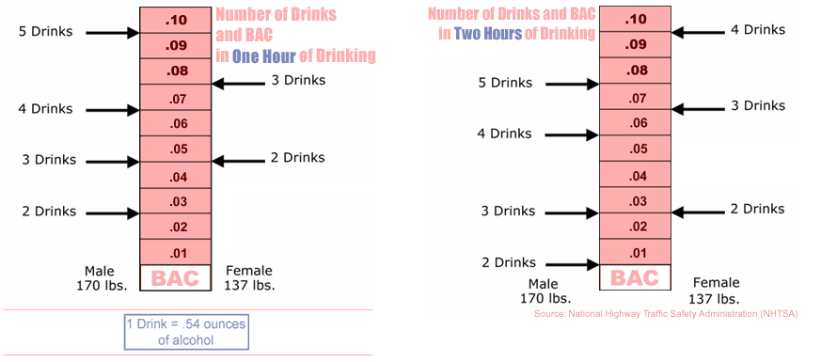
- 12-ounces of beer.
- 8-ounces of malt liquor.
- 5-ounces of wine.
- 1.5-ounces or a “shot” of 80-proof distilled spirits or liquor (e.g., gin, rum, vodka, or whiskey).

